SCREENSHOT
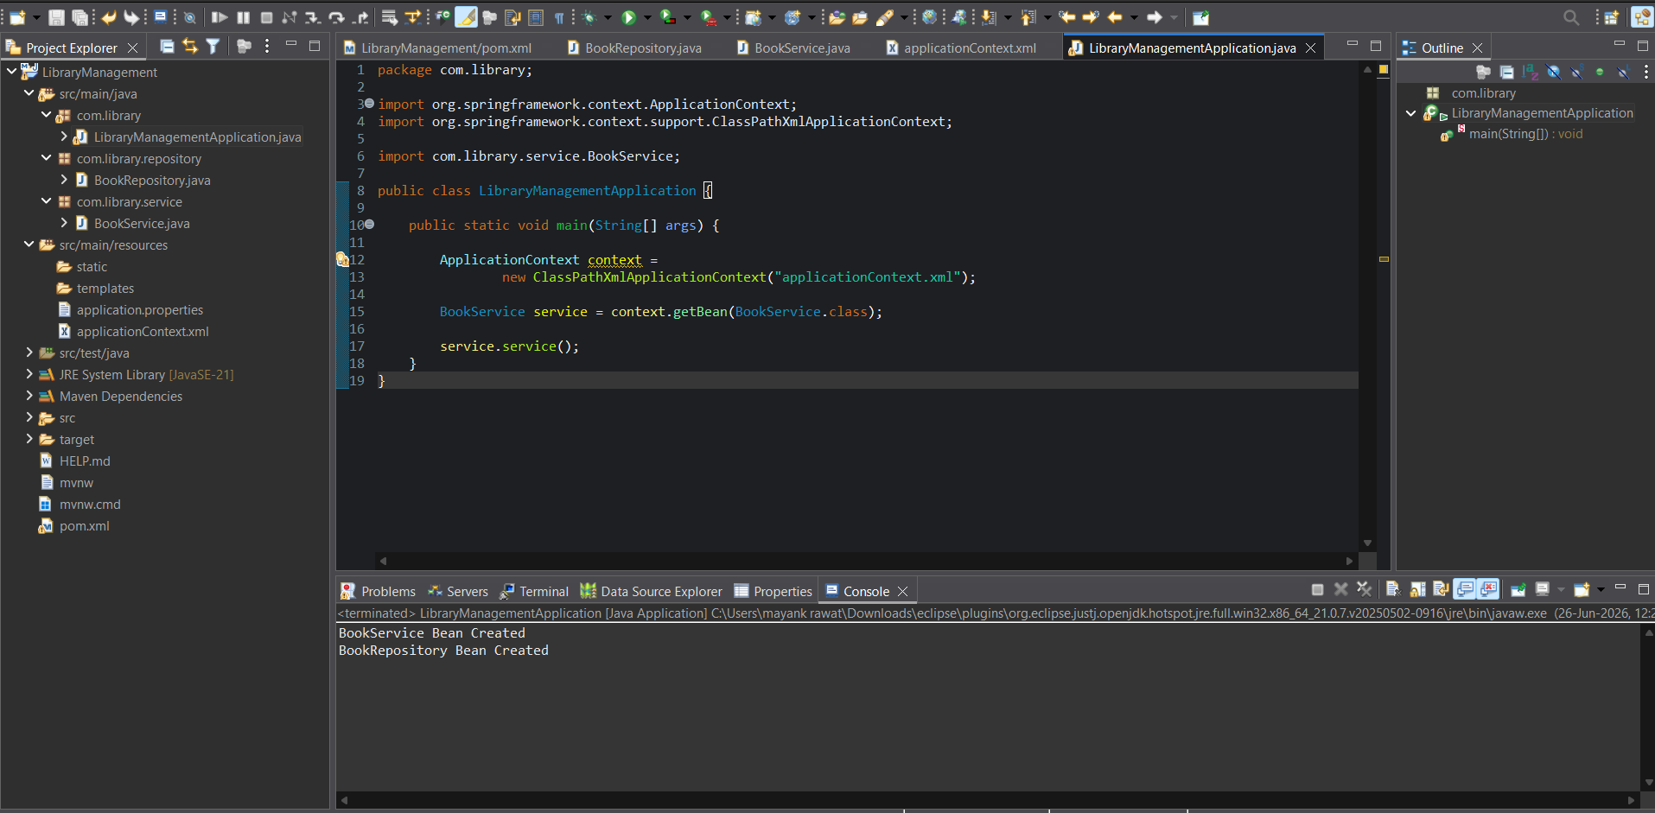

Pom.xml
<?xml version="1.0" encoding="UTF-8"?>
<project xmlns="http://maven.apache.org/POM/4.0.0"
xmlns:xsi="http://www.w3.org/2001/XMLSchema-instance"
xsi:schemaLocation="http://maven.apache.org/POM/4.0.0
https://maven.apache.org/xsd/maven-4.0.0.xsd">
<modelVersion>4.0.0</modelVersion>
<parent>
<groupId>org.springframework.boot</groupId>
<artifactId>spring-boot-starter-parent</artifactId>
<version>3.5.16</version>
<relativePath/>
</parent>
<groupId>com.library</groupId>
<artifactId>LibraryManagement</artifactId>
<version>0.0.1-SNAPSHOT</version>
<properties>
<java.version>21</java.version>
</properties>
<dependencies>
<!-- Spring Boot Web -->
<dependency>
<groupId>org.springframework.boot</groupId>
<artifactId>spring-boot-starter-web</artifactId>
</dependency>
<!-- Spring Context -->
<dependency>
<groupId>org.springframework</groupId>
<artifactId>spring-context</artifactId>
<version>6.1.8</version>
</dependency>
<!-- Spring AOP -->
<dependency>
<groupId>org.springframework</groupId>
<artifactId>spring-aop</artifactId>
<version>6.1.8</version>
</dependency>
<!-- Spring WebMVC -->
<dependency>
<groupId>org.springframework</groupId>
<artifactId>spring-webmvc</artifactId>
<version>6.1.8</version>
</dependency>
<!-- Testing -->
<dependency>
<groupId>org.springframework.boot</groupId>
<artifactId>spring-boot-starter-test</artifactId>
<scope>test</scope>
</dependency>
</dependencies>
<build>
<plugins>
<!-- Spring Boot Plugin -->
<plugin>
<groupId>org.springframework.boot</groupId>
<artifactId>spring-boot-maven-plugin</artifactId>
</plugin>
<!-- Maven Compiler Plugin -->
<plugin>
<groupId>org.apache.maven.plugins</groupId>
<artifactId>maven-compiler-plugin</artifactId>
<version>3.11.0</version>
<configuration>
<source>1.8</source>
<target>1.8</target>
</configuration>
</plugin>
</plugins>
</build>
</project>

